**PHYSICS**

**YEAR 12**

Semester Two Examination 2019

Question/Answer Booklet

Name: _______________________________________________________

Teacher: ___________________________________________________

***TIME ALLOWED FOR THIS PAPER***

Reading time before commencing work: Ten minutes

Working time for the paper: Three hours

Materials required/recommended for this paper

*To be provided by the supervisor*

This Question/Answer booklet

Formulae and Data booklet

*To be provided by the candidate*

Standard items: pens (blue/black preferred), pencils (including coloured), sharpener, correction fluid/tape, eraser, ruler, highlighters

Special items: non-programmable calculators approved for use in this examination, drawing

templates, drawing compass and a protractor

Important note to candidates

No other items may be taken into the examination room. It is **your** responsibility to ensure that you do not have any unauthorised material. If you have any unauthorised material with you, hand it to the supervisor **before** reading any further.

Structure of this paper

|  |  |  |  |  |  |
| --- | --- | --- | --- | --- | --- |
| Section | Number of questions available | Number of questions to be answered | Suggested working time (minutes) | Marks available | Percentage of examination |
| Section One  Short response | 11 | 11 | 50 | 54 | 30 |
| Section Two  Problem-solving | 7 | 7 | 90 | 90 | 50 |
| Section Three  Comprehension | 2 | 2 | 40 | 36 | 20 |
|  |  |  |  | **Total** | 100 |

**Instructions to candidates**

1. The rules for the conduct of the Western Australian external examinations are detailed in the *Year 12 Information Handbook 2019*. Sitting this examination implies that you agree to abide by these rules.
2. Write your answers in this Question/Answer booklet preferably using a blue/black pen.

Do not use erasable or gel pens.

1. You must be careful to confine your answers to the specific questions asked and to follow any instructions that are specific to a particular question.
2. When calculating or estimating answers, show all your working clearly. Your working should be in sufficient detail to allow your answers to be checked readily and for marks to be awarded for reasoning.

In calculations, give final answers to three significant figures and include appropriate units where applicable.

In estimates, give final answers to a maximum of two significant figures and include appropriate units where applicable.

1. **Supplementary pages for planning/continuing your answers to questions are provided at the end of this Question/Answer booklet. If you use these pages to continue an answer, indicate at the original answer where the answer is continued, i.e. give the page number.**
2. The Formulae and Data booklet is not to be handed in with your Question/Answer

booklet.

|  |  |
| --- | --- |
| Section One: Short response | 30% (54 Marks) |

This section has **12** questions. Answer **all** questions. Write your answers in the spaces provided.

When calculating numerical answers, show your working or reasoning clearly. Give final answers

to **three** significant figures and include appropriate units where applicable.

When estimating numerical answers, show your working or reasoning clearly. Give final answers

to a maximum of **two** significant figures and include appropriate units where applicable.

**Supplementary pages for planning/continuing your answers to questions are provided at the end of this Question/Answer booklet. If you use these pages to continue an answer, indicate at the original answer where the answer is continued, i.e. give the page number.**

Suggested working time: 50 minutes.

_____________________________________________________________________________

**Question 1 (4 marks)**

Give one example where each of the following light-based phenomena can be observed:

1. Dispersion (1 mark)

1. Reflection (1 mark)

1. Refraction (1 mark)

1. Polarisation (1 mark)

**Question 2 (6 marks)**

A photoemissive metal plate is used as the target sample in a photoelectric effect experiment.

When 320 nm light is used, a 0.685 V stopping voltage is required. When 250 nm light is used,

the stopping voltage is 1.77 V.

1. Explain why decreasing the wavelength of the light increases the stopping voltage.

(3 marks)

1. Calculate the work function of the photoemissive metal plate. (3 marks)

Answer: __________________ eV

**Question 3 (4 marks)**

Muons produced in a CERN experiment are travelling at 0.920 $c$ relative to the particle accelerator. They cover a 728 km distance as measured from the reference frame of the particle accelerator before hitting their intended target. Calculate the time the muon’s spend on their journey to the intended target from the reference frame of the muon.

Answer: __________________ s

**Question 4 (4 marks)**

In 2019, a dark matter detector that had been running for two years has not detected any dark matter but has detected 126 incredibly rare cases of xenon decay. In xenon decay, a pair of electrons are captured simultaneously by two protons and emit two neutrinos.

$$e+e+p+p→ ν_{e}+ν_{e}+n+n$$

Confirm whether this reaction is possible by checking conservation of baryon number and lepton number.

**Question 5 (5 marks)**

The graph below reveals the relationship between distance of galaxies from Earth and each

galaxy’s recessional velocity from Earth.

Recessional Velocity

Distance from the Earth

0

1. Explain what causes the relationship revealed in the graph. (3 marks)

1. Explain why the cluster of galaxies closest to Earth have a negative recessional velocity despite your answer to part (a). (2 marks)

**Question 6 (5 marks)**

Stars are approximate black bodies. Their colour can be used as reliable method of determining

the temperature of a star – a red star is cooler than a blue star. The spectrum of a red star is

shown below.

1. On the same axes, sketch the spectrum observed for a blue star. You may assume the

stars are identical apart from their temperature. (2 marks)

1. Explain how colour is an indication of the temperature of these stars. (3 marks)

**Question 7 (6 marks)**

An electron annihilates with its antiparticle, the positron to produce two gamma rays. In the rest frame of the annihilation, the two gamma rays have equal energy.

1. Calculate the rest energy of an electron. (2 marks)

Answer: __________________ J

1. If the electron and positron **each** had 2.05 × 10-13 J of kinetic energy prior to the annihilation, calculate the frequency of each gamma ray in the frame of the annihilation.

(4 marks)

Answer: __________________ Hz

**Question 8 (5 marks)**

A volley ball is served by hitting it at 12.8 m s-1 at 25.00 above the horizontal. The server made contact with the volleyball when it was 2.35 m above the ground. Find the horizontal range of

the volleyball serve. Air resistance can be ignored.

Answer: __________________ m

**Question 9 (4 marks)**

A boy pulls his 12.0 kg red cart up an incline of 15.00. While the cart moves up the incline, the friction between the wheels and the ground is 150 N and the boy pulls at 205 N along the incline. Calculate the acceleration of the cart.

15.00

Answer: __________________ m s-2

**Question 10 (5 marks)**

Electric cars utilise regenerative braking. By referring to both Faraday’s law and Lenz’s law,

explain the physical principles that help to recharge the battery and assist with slowing the

car down.

**Question 11 (6 marks)**

A single charged sodium ion (Na+) is moving at 1250 m s-1 within a 0.866 T magnetic field as shown below. The sodium ion has a 3.82×10-26 kg mass.

X X X X X X

X X X X X X

X X X X X X

X X X X X X

V

1. On the diagram above, draw the path the sodium ion follows. (2 marks)
2. Calculate the wavelength of the sodium ion. (2 marks)

Answer: __________________ m

1. Calculate the radius of the ion’s movement. (2 marks)

Answer: __________________ m

**End of Section One**

|  |  |
| --- | --- |
| **Section Two: Problem-solving** | **50% (90 Marks)** |

This section has **six** questions. Answer **all** questions. Write your answers in the spaces provided.

When calculating numerical answers, show your working or reasoning clearly. Give final answers to **three** significant figures and include appropriate units where applicable.

When estimating numerical answers, show your working or reasoning clearly. Give final answers to a maximum of **two** significant figures and include appropriate units where applicable.

Supplementary pages for planning/continuing your answers to questions are provided at the end of this Question/Answer booklet. If you use these pages to continue an answer, indicate at the original answer where the answer is continued, i.e. give the page number.

Suggested working time: 90 minutes.

_____________________________________________________________________________

**Question 12 (12 marks)**

Rovers have been sent to Mars to obtain samples from the planet’s surface. One such rover is approaching the surface of Mars at 25.0 m s-1 at an altitude of 300 m. The internal components of the rover require that the rover contacts the surface at a speed of no greater than 0.850 m s-1 to remain intact. To achieve this, a parachute is opened at this altitude to reduce the speed of the 1050 kg rover.

These details may be used to help answer the following questions:

* Mass of Mars: 6.42 × 1023 kg
* Radius of Mars: 3.38 × 106 m

1. Find the gravitational field strength at the surface of Mars. (3 marks)

Answer: __________________ N kg-1

1. Show by calculation that the work done by the parachute to ensure the rover makes contact with the surface at a safe speed is approximately 1.50 MJ. You may assume the gravitational field strength is constant between the ground and the 300 m altitude. (4 marks)

Answer: __________________J

1. Hence calculate the average air resistance acting against the parachute from the 300 m altitude until the rover makes contact with the ground. (2 marks)

Answer: __________________ N

1. Was the assumption made in part (b) reasonable? Justify your response. (3 marks)

**Question 13 (11 marks)**

Beta decay is the ejection of an electron from the nucleus of a radioisotope. The beta particle (electron) speed can vary, but for this question, assume they are ejected at 0.990c.

1. Taking Special Relativity into account, calculate the energy of the beta particle. (3 marks)

Answer: _______________ J

1. Two beta particles are ejected towards each other from two nuclei that are at rest relative to each other.

Calculate the speed of one beta particle as measured from the reference frame of the other. Give your answer to 6 significant figures and in terms of c. (3 marks)

Answer: _______________ c

1. Calculate the magnitude of the momentum of a beta particle as measured from the reference frame of the nucleus. (3 marks)

Answer: _______________ kg m s-1

1. Calculate the quantity of mass lost by the nucleus due to the beta decay event.

(2 marks)

Answer: _______________ kg

**Question 14 (13 marks)**

To help students’ visualise the workings of a generator, a demonstration generator is built using the design shown in the diagram below.

Generator

Transformer

N

S

Circular coil

Slip ring

Generator coil number: 18

Generator coil radius: 0.0700 m

Magnetic flux density: 3.00 mT

10 windings

530 windings

The demonstration generator is not capable of a high voltage output. To increase the output voltage, the demonstration generator was connected to a transformer. The primary to secondary windings ratio was 1:53, resulting in an rms output voltage of the transformer of 2.36 V.

1. Explain in detail how the rotation of the generator coil results in the generation of a

sinusoidal current delivered to the transformer. (5 marks)

1. Calculate the maximum flux that can be encased by the generator coils. (2 marks)

Answer: _______________ Wb

1. Calculate the rms voltage output by the generator which is delivered to the primary coil of the transformer. (2 marks)

Answer: _______________ V

1. Calculate the frequency of the rotation of the generator coils. If you could not obtain an answer to part (c), you may use a value of 4.00×10-2 V. (4 marks)

(Hint: First calculate the peak voltage from your answer to (c).

Answer: _______________ Hz

**Question 15 (14 marks)**

Consider the energy level diagram below, with a single electron in the ground state.

n=1

n=2

n=3

n=4

n=∞

n=5

-12.8 eV

-5.30 eV

-3.28 eV

-2.55 eV

-1.85 eV

0 eV

1. Calculate how much energy is required to move from the ground state to the n=2 energy level. (1 mark)

Answer: _______________ eV

1. On the energy level diagram, draw all the possible transitions an electron can make as it changes from the n=4 level to the n=2 level. (1 mark)
2. Calculate the largest wavelength of all possible photons produced as an electron makes a transition between n=4 and n=2. (4 marks)

Answer: _______________ m

1. A source of electromagnetic radiation (EMR) is used to promote an electron from the ground state to n=4. Which part of the electromagnetic spectrum does the EMR belong? Justify your answer with a calculation. (4 marks)

Answer: _______________

1. “To ensure the photons from the EMR source are able to excite electrons from the ground state to n=4, we should increase the frequency of the EMR source slightly”.

Comment on the suitability of this suggestion. (4 marks)

**Question 16 (15 marks)**

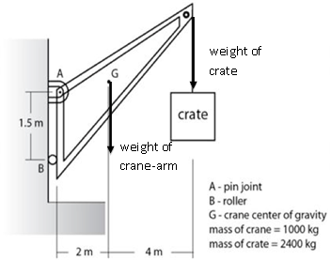In a mechanical workshop, a crane consists of a triangular crane-arm fixed to a wall by a pin joint at point A, as shown in the diagram at right. The crane-arm has a mass of 1000 kg centred at point G. The crane is being used to lift a heavy crate of mass 2400 kg, and has an adjustable roller at point B to help keep the vertical section of the crane-arm in place. Note that the roller only exerts a **horizontal force** on the crane-arm.

(a) On the diagram, draw in and label the other two forces acting on the crane-arm. (2 marks)

(b) Explain why the roller can only exert a horizontal force on the vertical section of the crane-arm. (2 marks)

(c) Explain why the length of the cable attaching the crate to the crane-arm was not specified in the diagram. (2 marks)

(d) Calculate the size of the horizontal force exerted by the roller on the crane-arm. (3 marks)

(e) Calculate the magnitude and direction of the reaction force exerted by the pin joint at point A on the crane-arm. (4 marks)

1. Explain how and why the size of the horizontal force exerted by the roller on the crane-arm would change if the roller was moved higher and closer to the pin joint at point A.

(2 marks)

_____________________________________________________________________________

_____________________________________________________________________________

_____________________________________________________________________________

__________________________________________________________________________________________________

**Question 17 (9 marks)**

An educational software package helps students understand electromagnetic principles by simulating a mini golf course. In this simulation, rather than hitting a ball into a hole with a putter, students must use electric charges to apply a force onto a charged golf ball to direct the ball towards the hole. Unlike real golf, there is no friction and the ball will not overshoot the hole because it is going too fast.

30.00

Hole

Ball

260 nC

140 nC

The charges $q_{A}$ and $q_{B}$ are located on the corners of the short edge of the putting area, equidistant from a golf ball. These charges share the same sign of charge as the golf ball, thus each repels the golf ball. Let the force acting on the golf ball due to charge $q_{A}$ be called $F_{A}$ and the force acting on the golf ball due to charge $q_{B}, F_{B}.$ Charge $q_{A}$ is 260 nC and the golf ball has a 140 nC charge.

1. To putt the golf ball towards the hole, the ball must travel 30.00 above the horizontal line,

as indicated in the diagram. Show that the ratio of electric forces acting on the golf ball,

$\frac{F_{B}}{F_{A}}$ is approximately 3.73 for a successful putt. Include a vector diagram as part of your answer.

Note that the diagram above indicates that a line from charge A to the ball and a line from charge B to the ball are at right angles to each other. (2 marks)

1. Hence, calculate the electric charge of $q_{B}$. (3 marks)

Answer: __________________ C

1. Assume that the distance from each charge $q_{A}$ and $q_{B}$ to the golf ball is 5.00 cm. Calculate the strength of the electric field at the golf ball’s starting position due to the combined effect of charges $q_{A}$ and $q_{B}$. (4 marks)

Answer: __________________ N C-1

**Question 18 (16 marks)**

Young’s double slit experiment is used as evidence of the wave nature of light. The experiment requires a monochromatic light source, a blocking screen with a pair of thin, parallel slits and an observation screen.

$$w$$

$$d$$

$$z$$

Light

Blocking Screen

Observation Screen

When the light is turned on, the observation screen has a repeating pattern of bright and dim fringes. The theoretical relationship between the distance between bright fringes ($w$), the separation of the slits ($d$) and the distance between the blocking screen and observation screen ($z$) is:

$$w=\frac{zλ}{d}$$

A 560 nm light was used and the distance between the fringes was recorded as the distance between the screens was increased. The results are given below.

|  |  |
| --- | --- |
| **(m)** | **(×10-3 m)** |
| 1.2 | 4.7 |
| 1.5 | 5.6 |
| 1.9 | 7.0 |
| 2.5 | 9.0 |
| 3.5 | 12.7 |

1. Explain the processes that occur that change the original light source into a pattern of

bright and dim fringes. (3 marks)

1. Show that as long as $z$, $d$ and $λ$ are measured in metres, the formula for calculating the

width between the fringes will return a value in metres. (1 mark)

1. Draw a graph of $w$ against $z$, with $w$ on the y-axis. Draw a line of best fit. Error bars

are not required. (5 marks)

A spare grid is provided on the end of this Question/Answer booklet. If you need to use it, cross out this attempt and clearly indicate that you have redrawn it on the spare page.

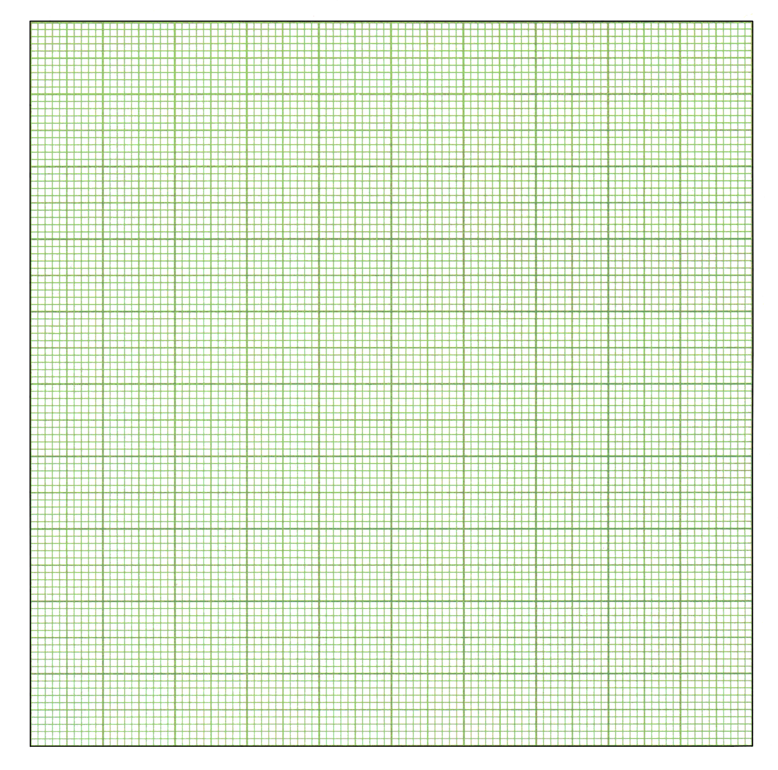

**Question 18** (continued)

1. Use the graph to calculate the gradient of the line of best fit. Show construction lines.

(3 marks)

Answer: _______________

1. Use the gradient from part (d) and the provided equation to calculate the width between the slits in this experiment. (4 marks)

Answer: _______________ m

**End of Section Two**

**This page has been left blank intentionally**

|  |  |
| --- | --- |
| **Section Three: Comprehension** | **20% (36 Marks)** |

This section has **two** questions. You must answer **both** questions. Write your answers in the spaces provided.

When calculating numerical answers, show your working or reasoning clearly. Give final answers to **three** significant figures and include appropriate units where applicable.

When estimating numerical answers, show your working or reasoning clearly. Give final answers to a maximum of **two** significant figures and include appropriate units where applicable.

Supplementary pages for planning/continuing your answers to questions are provided at the end of this Question/Answer booklet. If you use these pages to continue an answer, indicate at the original answer where the answer is continued, i.e. give the page number.

Suggested working time: 40 minutes.

**Question 19 (17 marks)**

**Experimental evidence supporting special relativity**

Prior to the development of Einstein’s theory of special relativity, it was proposed that light travelled through a medium called the luminiferous aether. Light needed a medium (according to physicists of the 1800s) because light had wave like behaviour. Wave models required the aether to exist, but no one could detect it. It was assumed the Earth moved through this aether and since the Earth orbits the Sun, the relative motion through the aether would be seasonal. The Michelson-Morley experiment, conducted in 1887, was an attempt to detect the velocity of the aether relative to the Earth.

**D**

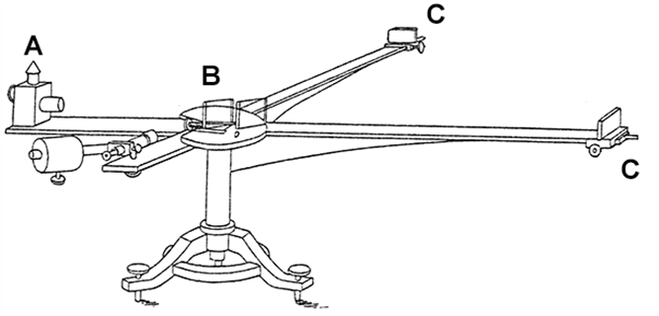

Expected v of aether

Original sketch of experimental setup of the Michelson-Morley experiment.

A: Oil Lamp

B: Beam Splitter

C and D: Mirrors

In the experiment, a source of white light from an oil lamp was passed through a beam splitter- each beam heads towards a reflective mirror spaced equally from the splitter. One beam has a velocity aligned with the direction the aether’s velocity (longitudinal beam, BC) while the other beam’s velocity was perpendicular to the velocity of the aether (transverse beam, BD). The longitudinal beam is now like a kayaker paddling upstream – the kayaker has a velocity he/she can achieve in still water (the light’s speed in the aether, which was believed to be **c**, 3 x 108 ms-1) but the velocity of the kayaker relative to the shore is reduced because of the water’s opposing flow (the aether flows against the light, reducing the light’s speed). The transverse beam is only minimally affected as it is trying to “cross the river”.

Mathematically, if the aether was flowing past the experiment at speed $v$, it is just as valid to say the experiment is moving in the other direction at speed $v$. The light moves at a speed $c$**within** the aether. When the longitudinal light passes through the beam splitter, a mirror is a distance $L$ from the splitter but is moving away from the light with a velocity $v$. In the time it takes for the beam to reach the mirror, $T_{1}$, the mirror has moved at distance $vT_{1}$ from its original position.

To mirror D

Source light

Longitudinal beam

Transverse beam

**X**

**Y**

Beam Splitter

$$L$$

$$L^{'}=vT_{1}$$

**X** – mirror C position when source light reaches beam splitter

**Y** – mirror C position when longitudinal beam reaches mirror

Relative positions of mirror C

This allows for an expression for the time it takes for the beam to travel from the beam splitter to reach the mirror: $T_{1}=\frac{L}{c-v}$.

The equipment of the day did not allow for such precise measurements of time. This is why the transverse beam was required, where $T_{2}=\frac{L}{c}$.

As the longitudinal and transverse beams recombined after being reflected at the equally spaced mirrors, the intensity of the recombined light would reveal the phase difference between the two beams, indicating the difference in travel time of the beams and thus velocity of the experiment through the aether.

By measuring results over many months, Michelson and Morley expected to find a variety of recombined intensities, thus a variety of results for $v$, the speed of the aether. However, the results revealed that the aether had no velocity – that is, both beams of light always had the same speed no matter when the experiment was conducted – contradicting everything that physicists of the time expected of the aether. This is now regarded as the most famous “failed” experiment in history.

1. The “failed” Michelson-Morley experiment was the basis for one of Einstein’s postulates of special relativity.
2. Contrast what Michelson and Morley hoped to find in this experiment with the final outcome. (2 marks)

**Question 19** (continued)

(ii) State the postulate this ‘failed’ experiment supports. (1 mark)

1. Assuming light does travel through an aether, show, via full working, that the time the longitudinal beam takes to move from the splitter to the mirror is $\frac{L}{c-v}$. (3 marks)
2. Assuming light travels through an aether, the anticipated **total** time it takes for the longitudinal beam to return to the splitter is **not $2×\frac{L}{c-v}$** (twice the time it took to move

from splitter to mirror). Explain. (3 marks)

1. Physicists in the 1800s assumed light used the luminiferous aether as a medium. If this was true, explain how using a beam splitter and recombination of longitudinal and transverse beams would result in changes in light intensity. (5 marks)

1. Even if the experiment was a “success”, the results were expected to change from one month to the next. Explain why. (3 marks)

**Question 20 (19 marks)**

**The barycentre – the true centre of a circular orbit**

Physics Unit 3 covers uniform circular motion due to gravitational forces acting on a satellite. The analysis of these problems is simplified by assuming the orbital radius is the distance between the centre of mass of the two bodies (e.g. Earth and Moon). However, consider this – as the Earth pulls on the Moon to give the Moon its centripetal force, the Moon also pulls on the Earth. Wouldn’t the Earth then begin to accelerate towards the Moon? In truth, it does. When any two celestial objects orbit each other, they orbit around a common central point, called the barycentre.

+

+

The two-body system diagrams above show that as the two bodies orbit the barycentre, their centres of mass are always radially opposite each other – each body has the same orbital period. Each body applies a gravitational force on the other, pulling it towards the barycentre. The bigger mass is always closer to the barycentre than the smaller mass.

Since the Earth is much more massive than the Moon, the barycentre is inside of the Earth. This causes the Moon to orbit around the Earth, while the Earth appears to “wobble”, as shown in the diagrams below. The Earth is still in a state of uniform circular motion about the barycentre and can be analysed as such.

+

+

+

+

For these two-body systems, the barycentre can be calculated from knowledge of the masses and total distance separating the two bodies:

$$r_{1}=\frac{d}{1+\frac{m_{1}}{m_{2}}}$$

$m_{1}$ and $m_{2}$ are the masses of body 1 and body 2

$r_{1}$ is the distance from the centre of $m_{1}$ to the barycentre

$d$ is the separation of the centre of masses of $m_{1}$ and $m_{2}$

1. Discuss whether the following statements are physically sound for a two-body system consisting of the Earth and Moon:
2. “Both the Earth and the Moon experience the same magnitude of gravitational force”. (3 marks)

1. “Both the Earth and Moon experience the same magnitude of centripetal acceleration.” (3 marks)

1. By drawing gravitational forces for the two-body system shown below, explain why it is **not** possible to have the bodies in the position shown in the diagram. (3 mark)

+

\

**Question 20** (continued)

1. Using the formula given on page 32, calculate the distance from the centre of the Earth to the barycentre of the Earth-Moon system. (3 marks)

Answer: m

1. Knowledge of the barycentre location allows the speed at which the Earth is orbiting the barycentre to be determined.
2. Show that the velocity of the Earth with respect to the barycentre of the Earth-Moon system is $v=\sqrt{\frac{Gm_{moon}r_{1}}{d^{2}}}$. (2 marks)
3. Hence, calculate the velocity of the Earth around the barycentre of the Earth-Moon system. If you could not obtain an answer to part (c), you may use 4.60 × 106 m.

(2 marks)

Answer: m s-1

1. Prove that if the two-body system is made of two bodies of identical mass, the barycentre is exactly equidistant from each body. (3 marks)

**End of questions**

Supplementary page

Question number: _________________

Supplementary page

Question number: _________________

Supplementary page

Question number: _________________

Spare grid

